ПОКАНА ЗА УЧАСТИЕ В ХАКАТОН
„ПРЕДИЗВИКАТЕЛСТВА ЗА ИНОВАЦИИ“

В рамките на проект InnoChange: Driving Change, Capacity Building Towards Innovative, Entrepreneurial Universities ще се проведе състезание от тип „хакатон“ от 3-4.12.21 г. Каним всички желещи студенти, които имат идеи, искат да работят в екип и да се състезават с други студенти. Всички участници ще получат сертификат, а първите 3 отбора – дипломи.

Участници: студенти от ПУ и други университети, които имат познания по разработка на софтуерни приложения
Провеждане: онлайн
Работен език: английски
Участие: в екип или самостоятелно

Очаквана работа: избор на предизвикателство от зададен списък
разработване на концепция, включваща иновация
разработване на бизнес модел
проучване на пазара
отразяване на технически детайли по реализация на подходящ софтуерен продукт
подготовка на презентация за предлаганите решения
представяне на презентацията (3 минути)

Регистрация за участие*: bit.ly/innochange
*Моля допълнително да изпратите вашите имена, тел. номер, имейл, факултет и университет на eledel@uni-plovdiv.bg
Детайли за събитието: 01.12.2021
Хакатон: 03-04.12.2021

За повече информация за хакатона: https://innochangeproject.eu/online-hackathon/
За повече информация за проекта: https://innochangeproject.eu/
https://uni-plovdiv.bg/pages/index/2340/
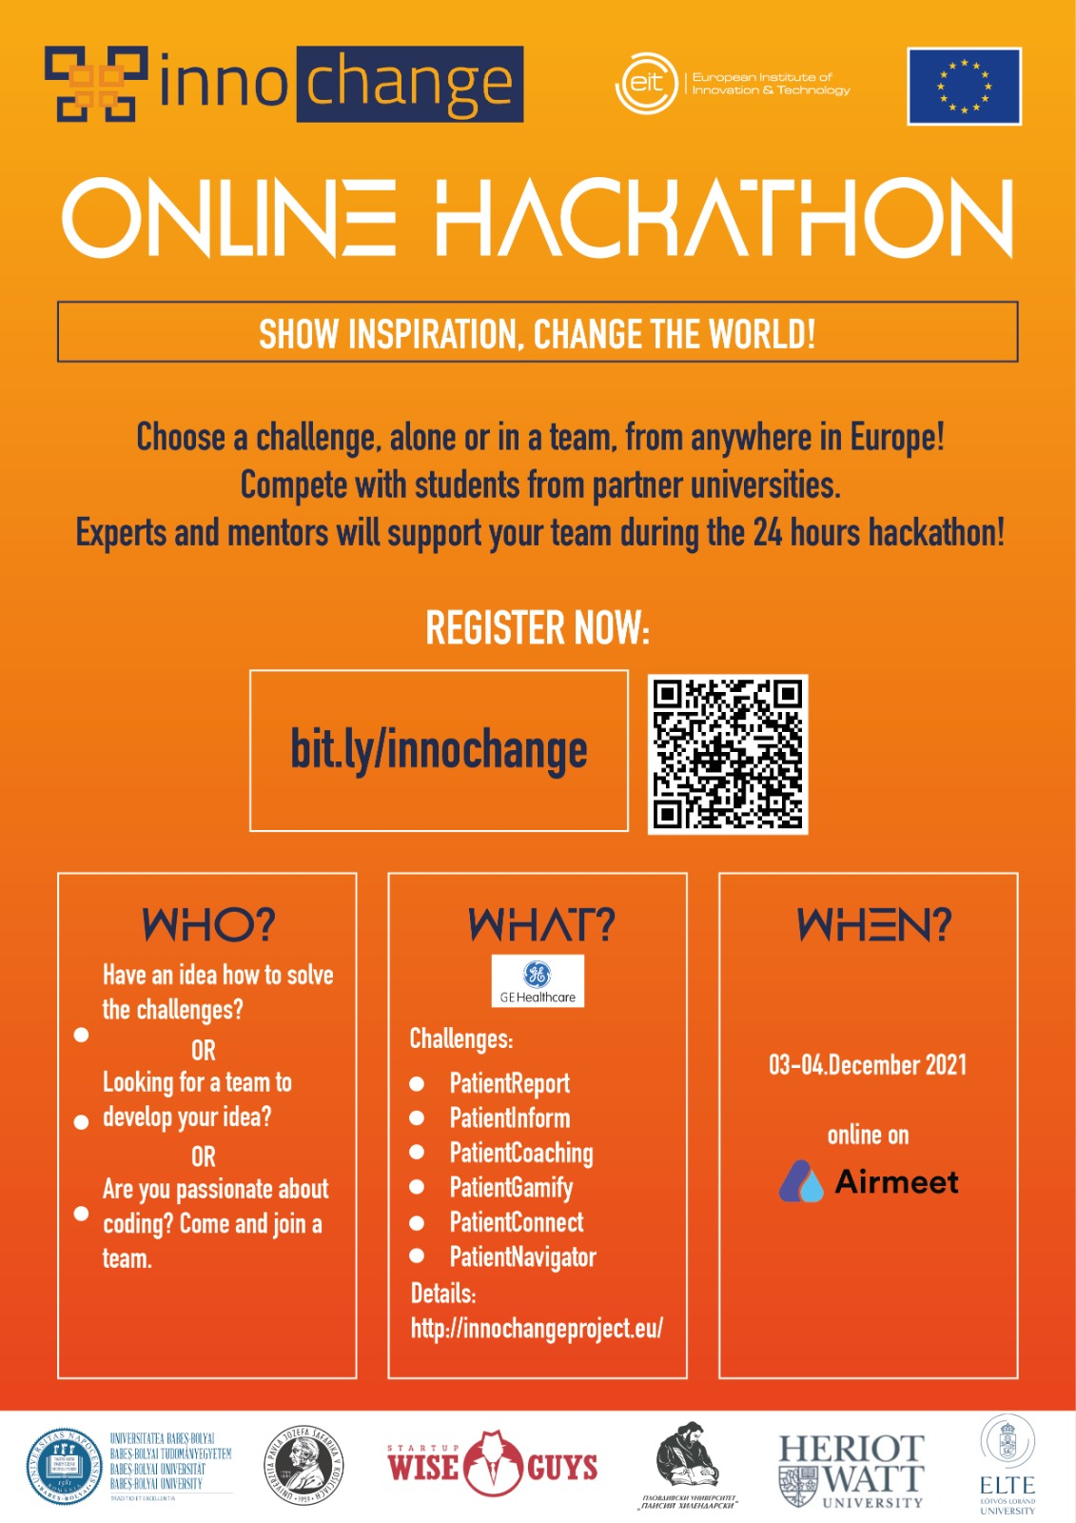
Challenges
Ideas and support from GE Healthcare

Abstract: Modern healthcare produces a tremendous amount of data and offers a huge variety of diagnostic and treatment options. Even for healthcare professionals it's a difficult challenge to collect, interpret and analyze all the available information and make the right decision for the patients. For the patients themselves it's even more difficult to digest all this information and make the right choices, since their medical knowledge is limited, they receive information from various sources in an unstructured way, they often get conflicting advices, they are deeply impacted personally and emotionally, and on top of everything, they are sick people.

PatReport
Patients are receiving health information from various sources in various formats, including lab reports with a lot of difficult to understand numbers, DVDs with medical imaging output in specialized file formats, printed radiologist reports full of scientific terms, etc. They may have a hard time collecting and storing all these in an organized way, understanding each of the inputs and obtaining a synthetic view of the whole situation.
This component intends to interface with the various information sources, collect, organize, and store all the data, and display them in a clear and understandable way. It may provide help in the interpretation of lab result, explanations for the medical terms, provide information about the proposed treatments, etc. While the interface is primarily targeted to patients, it should also be suitable for medical professionals, since the patient may want to discuss what he saw there with his doctor.

PatInform
In today's world the internet offers easily accessible information to everyone about various healthcare topics. But it can be challenging to navigate among the various information sources, to find relevant information related to a given set of symptoms, or to differentiate between reliable and unreliable sources. Some patients may easily jump to unjustified conclusions about the disease they have or follow some unscientific and potentially harmful advice in the hope of getting better.
This component intends to use the various collected health information to help the user finding relevant information on the internet. Search the net for various topics, like background information, treatment options, lifestyle recommendations, symptoms to watch for, etc., and score them according to level of relevance, level of reliability, level of difficulty to understand, etc.

PatCoaching
A patient's wellbeing may be strongly influenced by a potential wrong decision he makes about when he takes medication, when and what he eats, the types of exercises he does. He may also experience some unexpected new symptoms and may have to decide whether he should just wait to get better, take some medication, or go to the hospital immediately.
This component intends to use the available health information to provide real-time advice to the patient. It can track the schedule of medications and doctors' appointments and provide timely reminders about what needs to be done. It may also collect additional information from wearable devices, ask the patient about how he feels, ask about targeted symptoms, prompt him to take measurements (weight, blood pressure, temperature, etc.) and give advice about what the patient needs to do.

PatGamify
A sickness is emotionally trying, and some treatments plans need dedication from the patients, like keeping a diet, doing exercises, or taking drugs with unpleasant side effects. Some patients may lose motivation, and eventually a significant number of patients do not comply with the treatment plan.
The goal of this component is to motivate patients to adhere to the treatment plan and reward them for their efforts, like a computer game.

PatConnect
Some patients may find it difficult to discuss their problems with other people, especially if they want to keep it secret from others. They may also find that their loved ones can't efficiently help them because they were never affected by this disease.
The goal of this component is to connect the patient to other patients with similar health issues to exchange experiences and provide support to each other. This may work a bit as a dating app finding the best matches to the given patient, but also providing a platform for anonymous information exchange in pairs or in group chats.

PatNavigator
In big institutions patients may easily feel lost, not knowing where exactly they should go, how long they will have to wait and what will happen to them.
This component collects information from a hospital system to help patients to navigate within the building, find the place of the next examination(s), show where they are in the overall process, show the expected waiting time, provide automatic reminders for the next appointment, checklist about the preparations to be made, etc.

About Hackathon

We invite students from different background that have ideas, have expertise, want to work in a team and compete with other students.
The solutions will be evaluated based on final 3 minutes pitch considering the criteria:
Concept and Innovation 30p
Business Model 20p
Market study 10p
Presentation 20p
Team work 10p
Technical advantage 10p

Local Organizers:
Simona Motogna simona.motogna@ubbcluj.ro
Dan Suciu dan.suciu@ubbcluj.ro
Florentin Bota florentin.bota@ubbcluj.ro
Adina Rus adina.rus@ubbcluj.ro

